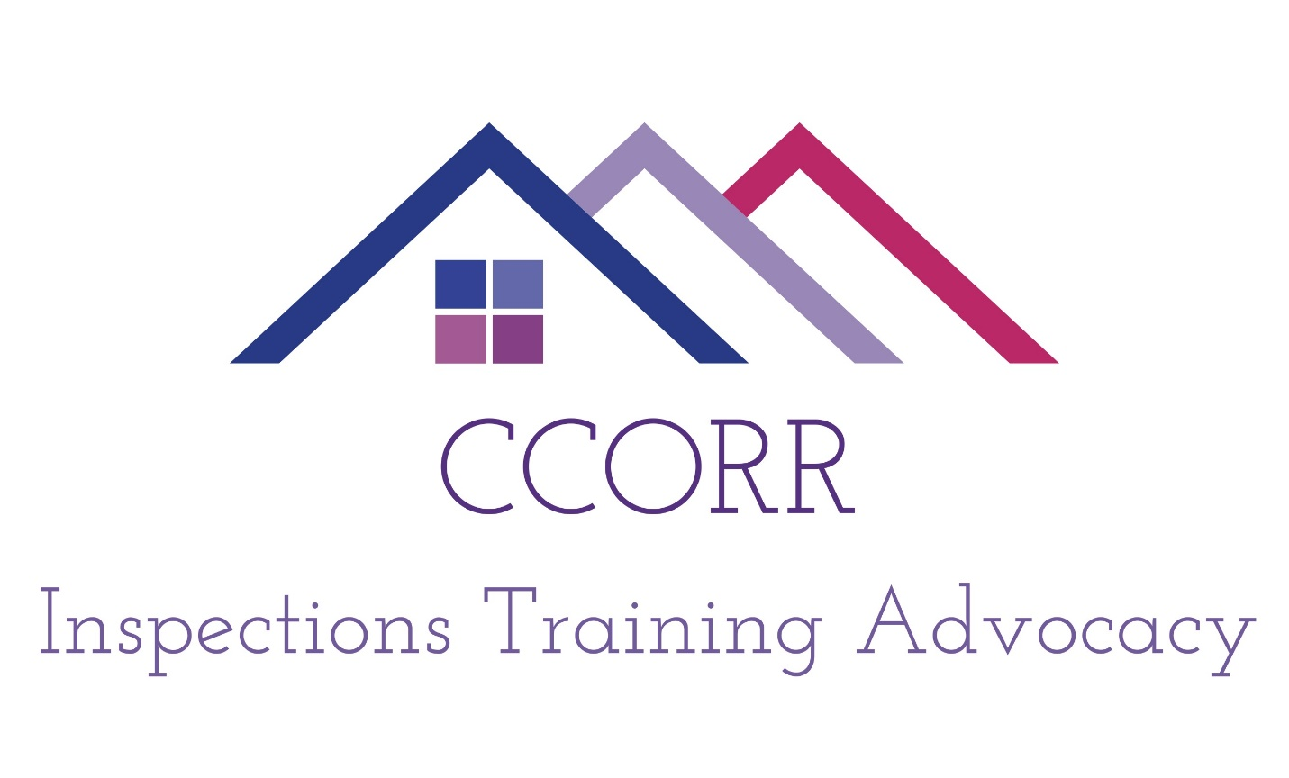2018

2018
Inspection Report
Recovery Residence:_____________________________________

Section A: Organizational/Administrative Standards: General Policies and Procedures
A1. Name of Provider Organization: The legal entity that owns/operates the recovery residence.
A1.1 If the operator is not the owner of record of the residence, is there written permission from the owner to operate a recovery residence on the property?* _____Yes ____No
A2. Provider Address: List the address where the provider wishes to receive official mail.
Address
City
State Zip code
Type of Dwelling ❏House ❏Duplex / Four-plex ❏Apartment ❏Dorm ❏Commercial property ❏Other
A3. Person who will be present at the Peer Review: List the individual who is authorized by the provider organization to be the representative of record.
Last Name
First Name
Title
Phone number
A4. Please provide your mission statement. ____________________________________________________________________________________________________________________________________________________________________________________________________________________________________________________________________________________________________________________________________________________
A5. Do you agree to abide by CCORR’s Code of Ethics? ___ Yes ___No (Please explain: _________________________________________________________
Please attach your House Rules and copy of Insurance Declarations Page
A5a. CCORR Code of Ethics is shared with residents by: (please check all that apply)
[ ] It is posted /displayed in the house. [ ] It is distributed to residents, staff and volunteers. [ ] It is kept in a binder or folder in a place that is easy to access by residents and staff
A6. What type of accounting system is used to document resident financial transactions, such as fees, payments and deposits? [ ] None [ ] Accounting software [ ] A handwritten bookkeeping ledger system [ ] Other ______________
A7. Is the accounting system identified above capable of generating a resident’s payment invoices and receipts? ___Yes ___No
A8. Are residents allowed to enter into paid work agreements with any of the following? [ ] Owner/operator [ ] Individuals who are employed by the residence [ ] Contractors of the recovery residence [ ] Volunteers of the recovery residence [ ]Other residents [ ] None of the above
A9. If paid work agreements are allowed, are there policies and procedures that ensure any of the following? Choose all that apply. [ ] Not applicable. No paid work agreements are allowed. [ ] Paid work arrangements are completely voluntary.[ ] Residents do not suffer consequences for declining work. [ ] Residents who accept paid work are not treated more favorably than residents who do not. [ ] Paid work for the operator does not impair resident’s progress towards their recovery goals. [ ] The paid work is treated the same as any other employment situation. [ ] Wages are commensurate with marketplace, value, and at least minimum wage. [ ] The arrangements are viewed by a majority of the residents as fair. [ ] Paid work does not confer special privileges on residents doing the work. [ ] Work relationships do not negatively affect the recovery environment or morale of the home. [ ] Unsatisfactory work relationships are terminated without recriminations that can impair recovery.
A10. What is your relapse policy? [ ] Zero-tolerance approach. Documented usage of predefined substance(s) results in the resident moving out of the RR, no exceptions. [ ] Intervention approach. Documented usage of predefined substance(s) results in a intervention response which most often includes requiring the resident to move out of the RR. [ ] Other __________________________________________________________________________
A11. What are your policies around hazardous or prohibited items? Choose only those that apply. [ ] None. [ ] Hazardous items (e.g. syringes) are prohibited. [ ] Staff have the ability to search for hazardous items. [ ] Residents, volunteers and staff are required to report hazardous items. [ ] Other ___________
A12. What procedures are used to collect, evaluate and report accurate process and outcomes data for continuous quality improvement? (Please inform the applicant of the CCORR Outcomes Database at this time). _________________________________________________________________________________________________________________________________________________________________________________________________ * Not required.
A 13. Alumni are invited or encouraged to participate in current recovery residence roles or activities: ____ Yes ____No
A14. Residents are encouraged or expected to have recovery plans, which: Choose only those that apply. [ ] Are person-driven, meaning residents participate in the development of their own plan [ ] Promote life skills development by holistically assessing a resident’s strengths, needs and/or priorities [ ] Include an exit plan, meaning residents identify how they will support and bolster their recovery if and when they move out or are required to leave recovery residence services.[ ] Include a lifelong plan, meaning it looks beyond the program timelines
A15. What process(es) are in place that ensures resident voices can be heard? Check only those that apply. [ ] None [ ] Grievance process [ ] Resident council [ ] Alumni or peer council [ ] Residents can make some decisions or rules that govern their resident community χ Other __________
A16. How are peer staff and/or peer leaders used in meaningful ways? Choose only those that apply. Add others as needed to be more complete. [ ] No peer leadership. Seeking variance. [ ] Resident’s responsibilities increase with their length of stay or progress in their recovery [ ] Staffing or leadership plan that formally includes a peer component [ ] Written job description and/or contracts for peer staff and leadership [ ] Other _______________
A17. Does the staffing or leadership plan include current residents, and where possible former residents that model recovery principles? No _____Yes _____
No A18. In general, how are residents made aware of community resources, events and activities? ___Resource directories ___Resource Binder ___Bulletin Board ___Other
A19. Resident Schedules and Staffing Plans* Please indicate “Yes” or “No” to the right of each question.
Is there a weekly schedule of recovery support services posted?
Is a weekly schedule of recovery-oriented presentations, group exercises and activities posted?
Is there a weekly schedule of formal life skills development services or classes posted?
Is there a weekly schedule of clinical services posted?
For the above services that were checked with a “Yes”, is there a staffing plan that corresponds with the delivery of these services? ___Yes ___No
A20. What types of activities are hosted by the recovery residence, its alumni or its residents where members of the local recovery community are invited to attend? Choose only those that apply. [ ] None [ ] Mutual aid (e.g. 12 Step) meetings [ ] Celebrations [ ] Recreation activities [ ] Service work projects [ ] Other _____
A21. How are residents encouraged to find a recovery mentor or mutual aid sponsor: Choose only those that apply. [ ] From the greater recovery community [ ] From a pool of alumni or volunteers [ ] From a pool of staff [ ] Not encouraged to have a mentor or sponsor [ ] Other _________________________
A22. How are residents connected with other recovery organizations/groups? Choose only those that apply. [ ] Mutual aid societies (e.g. 12 Step Fellowships) [ ] Peer-led Recovery Community Organizations [ ] Recovery Community Centers [ ] Recovery Ministries [ ] Recovery advocacy organizations [ ] Other ____________________
Please indicate the Level that most closely resembles your House. [ ] Level One [ ] Level Two [ ] Level Three [ ] Level Four

